ECE230 Final Project
The Concentration Game
Zach Kelly and Tanner Brammeier

Introduction
Our final project will be a simple implementation of the game Concentration, using many of the skills we have learned in ECE230. The game will consist of two players, each with their own instance of the game running on different PIC16F887 microcontrollers, which will use serial communication to interact with each other. Each board will have several input and output devices, including two LCDs (one to display cards, and another for scores), a joystick and push button combo, a speaker, and an RGB LED. Once the boards detect that they are connected, they will pseudo randomly choose a starting player and card configuration. Each player will then use the joystick and push button to select two cards on their turn, gaining a point if they make a match. Different sound effects will be played for making a match or failing, winning the game, etc. The RGB LED will also be used to provide light effects for these events. The boards will use serial communication to synchronize scores, card configurations, and any other information critical to the game. The game will end when all of the cards have been matched.
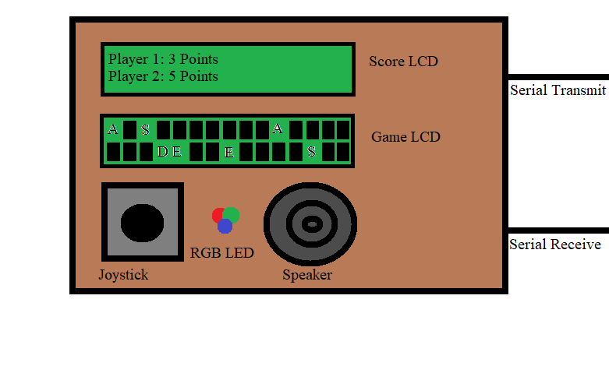
Figure 1: Game layout concept

Objectives and Specifications
- Manage several inputs and outputs simultaneously.
- Handle events occurring at random times.
- Write efficient code, so inputs and outputs aren’t affected by bad or slow timing.
Conceptual Design
- Both player scores will be shown on one LCD
  - This LCD will use 4-bit mode.
- The state of every card will be displayed on another LCD
  - Cards can be permanently flipped (matched), temporarily flipped (player is looking for a match), or unflipped.
  - This LCD will also use 4-bit mode.
- Player input will be received from the joystick and push button combination.
  - Used to move a blinking cursor around the LCD and select cards.
- Sounds will be plated with the speaker and the RGB LED will be used for light effects for specific events.
  - A player correctly matches two cards.
  - A player incorrectly matches two cards.
  - A player wins.
- Serial communication will be used to synchronize important game state information, such as card choices, scores, and whose turn it is.
  - The exact protocol used will be determined after we have finished learning about serial communication in class.
Tasks and Priorities
- Create a flowchart generally describing how the program will operate.
- Create a system schematic detailing how each component is connected to the PIC16F887 microcontroller.
- Assemble two identical boards, one for each player.
- Write code to display the appropriate words and graphics on each LCD.
- Write code to process input from the joystick and push button combination.
- Write code to track player scores.
- Write code to send and receive information between microcontrollers.
- Write code to provide light and sound effects from the RGB LED and speaker.
- Fix any remaining issues with the project.

Schedule
ECE 230 Final Project Schedule (The Concentration Game)
Task | M | T | W | T | F | S | S | M | T | W | T | F | S | S | M | T
Task | 10 | 11 | 12 | 13 | 14 | 15 | 16 | 17 | 18 | 19 | 20 | 21 | 22 | 23 | 24 | 25
Create System Flowcharts
Draw Wiring Schematics
Assemble Parts
LCD Display Code
Joystick Selector Code
Scoring Code
Board 1 and 2 Coms. Code
LED and Speaker Displays Code
Test and Debug
Final Presentation

Budget
ECE 230 Final Project Budget (The Concentration Game)
Qty | Part | Description | Cost
2 | PIC16F887 | This runs the games & controls the inputs and outputs | ECE 230 Kit
4 | LCD Module | Displays score & cards for matching | ECE 160 Kit
2 | Joystick w/ Select Button | Used for moving to a card & selecting it | ECE160 Kit
2 | RGB LED | Displays if you have a match or not & celebrates a win | ECE 230 Kit
2 | High Freq. Oscillator | 16 MHz oscillator to increase our operating frequency | $2.00
2 | Speaker | Plays tones for wins & right/wrong matches | ECE 230 Kit
2 | Breadboard | Houses all of the components for the game | ECE 230 Kit
- | Misc. Parts | Resistors, wires, etc... | ECE 160 Kit
- | Misc. Decorations | Covering & Decorations | Acquired
 |  | Total Cost: | $2.00

